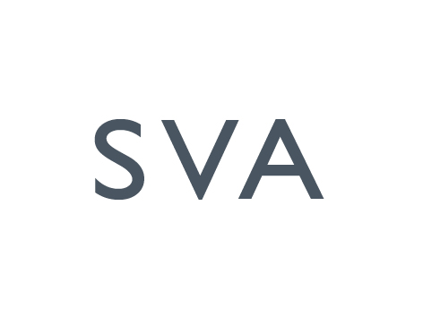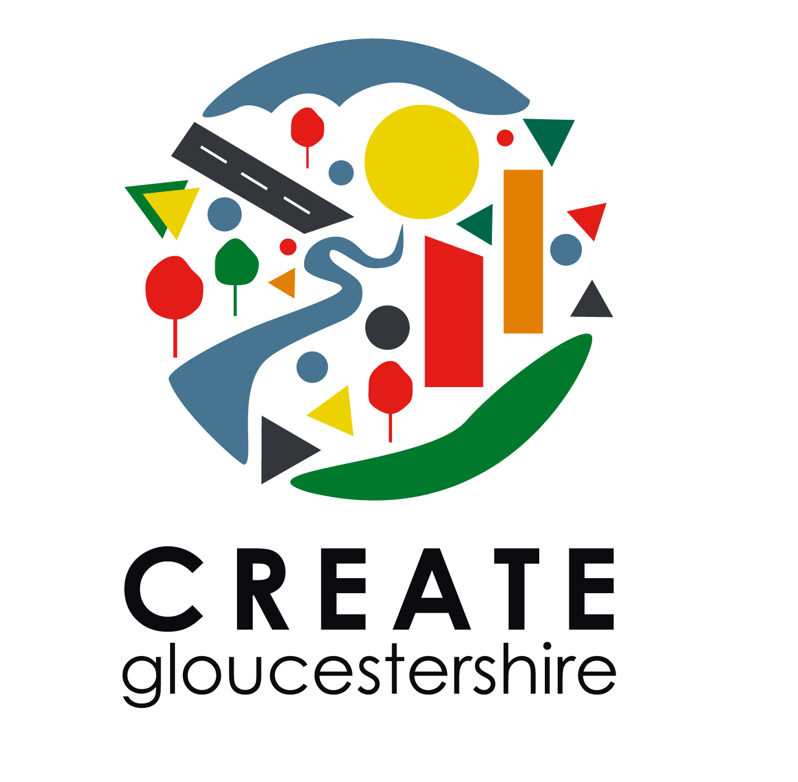
Arts Education Bursary scheme

Professional development brief for artists

Led by SVA and supported by Create Gloucestershire

Contact Details
Name:
Address

Phone No Mobile:

Email

Website

Self employed Yes No
(please tick)

- How would you define your practice?

- Do you have experience of working with schools already? Yes No
If yes, please give brief description.

- What is your professional development proposal? Please state if you already have particular contacts with schools, mentors or educational training schemes which you wish to develop.

- How much are you are applying for? (Please provide breakdown and quotes for equipment where necessary)

- When would this activity take place? (state start and finish dates)

- How will this benefit your development as an artist in the arts education sector?

Please email application form and attachments to office@sva.org.uk or send by post to SVA, 4 John Street, Stroud, Glos. GL5 2HA by : Friday 10th February or Friday 2nd March

